* **EDUTAINERS**

**Specialist of Sciences Date: 18/01/17**

**Bio Ch # 1 T4 1st year Time: 1hr 15 min Marks: 40**

**Name: _________________________ Objective**

**Q1: (1 x 10 = 10)**

|  |  |  |  |  |  |
| --- | --- | --- | --- | --- | --- |
| **(A)** | **(B)** | **(C)** | **(D)** | **Tick the right options.** |  |
| 0.35% | 0.25% | 0.15% | 0.05% | **Percentage of sodium in Human is** | **i** |
| Sexual | Asexual | Both | None | **Cloning is a type of which reproduction.** | **ii** |
| Lead | Fe | Chromium | Mercury | **Which of following is released from tranneries?** | **iii** |
| Macromolecule | Macromolecule | Inorganic Molecule | None | **Glucose is a _________ Molecule.** | **iv** |
| Ribosome’s | RER | SER | Both ‘a’ and ‘b’ | **Enzymes are synthesized by which of following organelle.** | **v** |
| 1000 | 2000 | 3000 | 4000 | **First living organism appears how many million years ago.** | **vi** |
| Plants | Animals | Insects | Fungi | **Which of the following has maximum number of organisms?** | **vii** |
| Gave therapy | Biological Control | Bioremediation | Chemotherapy | **Algae reduce pollution. This is called as** | **viii** |
| 65% | 18% | 3% | 2% | **Percentage of calcium is body is** | **ix** |
| Parasite logy | Microbiology | Biotechnology | Ecology | **Study of Relation between biotic and abiotic factor is called as:** | **x** |

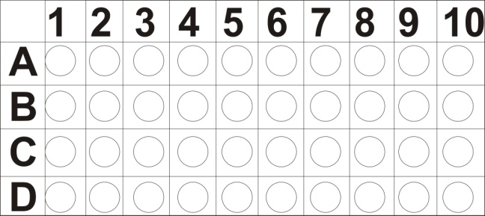

**Subjective**

**Q No 2: short question (2 x 11 = 22)**

|  |  |  |
| --- | --- | --- |
| **1)** | How does law differ from theory? | **2)** Differentiate b/w population & community |
| **3)** | Define integrated disease management give its importance | **4)** Write down the 4 way to from hypothesis? |
| **5)** | Define parasitology along with an example | **6)** Write down the names of era in geological time chart |
| **7)** | Define bioremediation | **8)** Differentiate b/w gene therapy & chomotherapy |
| **9)** | Write a short note on gene therapy | **10**) Write down the percentages of bioelement by mass of human being: (a) nitrogen (b) maganese (c) potassium (d) calcium |
| **11)** | Give the name of element in trace. |  |

**Q no. 3: (Long Questions) (4 + 4 = 8)**

|  |  |
| --- | --- |
|  | 1. Discuss briefly phyletic lineage in biological organization? 2. What is role of biology in the disease control |